Project Report Format
1. PROJECT TITLE
“Heart Disease Risk Analysis and Visualization using Tableau”
This project focuses on analyzing heart disease datasets and transforming complex healthcare data into interactive dashboards using Tableau. The aim is to help healthcare professionals, policymakers, and individuals understand risk factors and trends associated with heart disease.

2. PROJECT DESCRIPTION
2.1 System Overview:

The Heart Disease Analysis using Tableau project is a data visualization and analytics system designed to analyze medical datasets related to cardiovascular health. The system converts raw health data into interactive visual dashboards that help users identify patterns, correlations, and risk factors related to heart disease.
The project uses Tableau, a powerful business intelligence and data visualization tool, to create interactive charts and dashboards. These dashboards allow users to filter and analyze data based on several factors such as age, gender, cholesterol levels, blood pressure, body mass index (BMI), smoking habits, and physical activity levels.
By presenting the information visually, the system helps users easily interpret complex datasets and make informed decisions regarding healthcare and prevention strategies.

2.2 Problem Domain:

Heart disease remains one of the leading causes of death globally. Many factors contribute to heart disease, including unhealthy lifestyle habits, lack of exercise, smoking, high cholesterol levels, and high blood pressure.
Healthcare institutions collect large amounts of patient data, but analyzing these datasets manually is challenging and time-consuming. Without proper analytical tools, identifying meaningful trends and correlations becomes difficult.
The challenge addressed in this project is the transformation of large healthcare datasets into meaningful insights that help doctors and policymakers identify risk patterns and develop preventive healthcare strategies.

2.3 Core Technology Used:

The project primarily relies on the following technologies:
Tableau-
Tableau is a data visualization tool used to create interactive dashboards, charts, and graphs. It allows users to connect datasets and perform visual analytics without extensive programming knowledge.
Microsoft Excel / CSV Dataset-
The heart disease dataset is stored in Excel or CSV format. It contains structured healthcare data that is imported into Tableau for visualization.
Data Analytics Techniques-
Data analysis techniques such as filtering, grouping, trend analysis, and correlation analysis are used to understand relationships between health indicators and heart disease.

2.4 Key Capabilities:

The system provides several important capabilities:
- Visual analysis of heart disease risk factors
- Interactive dashboards for exploring healthcare data
- Identification of high-risk patient groups
- Comparison of medical indicators across different age groups and genders
- Trend analysis for lifestyle habits such as smoking and physical activity
- Easy-to-understand charts for healthcare decision-making

2.5 Target Users:

The system is designed for the following user groups:
Healthcare Professionals-
Doctors and cardiologists can use the dashboards to identify patients at higher risk of developing heart disease.
Healthcare Researchers-
Researchers can study correlations between lifestyle factors and cardiovascular conditions.
Government Health Departments-
Public health authorities can analyze trends in heart disease prevalence and design preventive policies.
Individuals-
People interested in monitoring their health can understand how lifestyle factors influence heart disease risk.

2.6 Real-world Relevance:

This project has significant real-world importance because heart disease is a major public health concern worldwide. By analyzing healthcare datasets and visualizing them through dashboards, the project helps:
- Improve preventive healthcare awareness
- Support medical research
- Assist policymakers in designing public health strategies
- Encourage individuals to adopt healthier lifestyles

3. APPLICATION SCENARIOS / USE CASES
3.1 Hospital Data Analysis
Hospitals generate large amounts of patient data related to heart disease. Using Tableau dashboards, healthcare professionals can analyze patient records and identify high-risk individuals based on medical indicators such as cholesterol levels, blood pressure, and BMI.
3.2 Government Health Policy Planning
Government health departments can analyze regional health data using the dashboards. This allows them to understand patterns in heart disease prevalence and design targeted health awareness campaigns or preventive programs.
3.3 Medical Research
Medical researchers can use the system to explore relationships between lifestyle factors and heart disease. The dashboards make it easier to identify correlations between variables such as smoking, obesity, and physical inactivity.
3.4 Personal Health Awareness
Individuals can use simplified dashboards to compare their health indicators with healthy benchmarks. This helps them make informed lifestyle choices to reduce their risk of developing heart disease.

4. TECHNICAL ARCHITECTURE OVERVIEW
4.1 High-Level Architecture Diagram

The system architecture consists of several layers:
Data Source → Data Cleaning → Tableau Data Connection → Data Visualization → Interactive Dashboard → Users

4.2 Component Interaction

Data Source Layer:
This layer contains the heart disease dataset, which includes patient demographic information and medical indicators.
Data Processing Layer
In this stage, the raw data is cleaned and prepared. Missing values are handled, duplicate entries are removed, and data is organized into structured tables.
Visualization Layer
Tableau connects to the processed dataset and generates visualizations such as charts, graphs, and maps.
Dashboard Layer
Interactive dashboards are created using Tableau to allow users to explore data through filters and parameters.
User Layer
End users interact with the dashboards to analyze trends and make decisions.

4.3 Data Flow:

- Heart disease dataset is collected from healthcare sources.
- Data is cleaned and structured using Excel or preprocessing tools.
- Clean data is imported into Tableau.
- Tableau creates visualizations based on selected fields.
- Dashboards present insights to users.

5. PREREQUISITES
5.1 Software Requirements:
The following software tools are required:
- Tableau Desktop / Tableau Public
- Microsoft Excel
- Operating System: Windows 10 / macOS
5.2 Libraries / Frameworks / Dependencies:

The project mainly relies on Tableau’s built-in visualization engine. Additional dependencies include:

Tableau visualization libraries

Excel data processing tools

5.3 Hardware Requirements (If Applicable):

Minimum system specifications include:

Processor: Intel Core i3 or higher

RAM: Minimum 4GB (8GB recommended)

Storage: 1GB free space

Display: Standard monitor resolution

6. PRIOR KNOWLEDGE REQUIRED
Concepts required before implementation:
- Programming language knowledge
- Framework basics
- Database fundamentals
- Networking / Cloud concepts
- AI/ML fundamentals (if applicable)

7. PROJECT OBJECTIVES
Technical Objectives
- Develop interactive dashboards for heart disease analysis
- Visualize healthcare datasets effectively
Performance Objectives
- Ensure fast and responsive data visualization
Deployment Objectives
- Enable dashboards to be shared online through Tableau Public
Learning Outcomes
- Gain practical experience in data visualization
- Understand healthcare data analysis methods

8. SYSTEM WORKFLOW
The system operates through the following workflow:
- User opens the Tableau dashboard.
- Heart disease dataset is imported.
- Data is processed and categorized.
- Tableau generates visual charts and graphs.
- Users interact with filters and parameters.
- Insights and analysis results are displayed.

9. MILESTONE 1: REQUIREMENT ANALYSIS & SYSTEM DESIGN
9.1 Problem Definition:

Heart disease is one of the leading causes of death worldwide. Healthcare organizations collect large volumes of patient data containing information about age, cholesterol levels, blood pressure, BMI, and lifestyle habits. However, analyzing this data manually is difficult and time-consuming.
The problem addressed in this project is the need for a system that can transform raw healthcare data into clear visual insights. By using Tableau dashboards, users can easily identify trends, risk factors, and high-risk patient groups.

9.2 Functional Requirements:

- Import heart disease dataset from Excel or CSV.
- Process and organize the data for analysis.
- Generate charts and graphs to visualize health indicators.
- Provide interactive filters for parameters such as age, gender, and cholesterol level.
- Display dashboards that summarize key insights.
- Allow users to export reports if needed.

9.3 Non-Functional Requirements:

- Usability: Dashboards should be easy to understand and user-friendly.
- Performance: The system should process and visualize data quickly.
- Reliability: The system should generate accurate and consistent visualizations.
- Security: Sensitive health data should be handled securely.
- Scalability: The system should support larger datasets in the future.

9.4 System Design Decisions:

- Tableau is used as the primary tool for data visualization.
- The heart disease dataset is stored in Excel/CSV format for easy integration.
- Interactive dashboards are designed with filters and charts to allow users to explore the data effectively.

9.5 Technology Stack Selection Justification Include:

- Architecture diagram
- ER diagram (if applicable)
- API structure (if applicable)

10. MILESTONE 2: ENVIRONMENT SETUP & INITIAL CONFIGURATION

10.1 Development Environment Setup:

The development environment includes the software and tools required for creating the data visualization dashboards.
The following tools were used:
- Tableau Desktop / Tableau Public for creating dashboards and visualizations
- Microsoft Excel for storing and preparing the dataset
- Operating System: Windows or macOS
Tableau was installed and configured to connect with the heart disease dataset stored in Excel format.

10.2 Dependency Installation :

This project requires minimal dependencies because Tableau provides built-in visualization capabilities.
Required components include:
- Tableau Desktop or Tableau Public
- Microsoft Excel for dataset preparation
- Heart Disease dataset (CSV or Excel format)
After installing Tableau, the dataset is imported directly into Tableau for analysis and visualization.

10.3 Project Structure Creation :

To maintain proper organization of files, a structured project directory is created.

10.4 Configuration Setup Include:

The configuration process involves connecting Tableau to the dataset and preparing it for visualization.
Setup Steps:
- Install Tableau Desktop or Tableau Public.
- Open Tableau and select Connect to Data.
- Choose the dataset file (CSV or Excel).
- Load the dataset into Tableau.
- Verify that all fields such as age, cholesterol, BMI, and heart disease status are correctly detected.

Configuration Explanation
Once the dataset is loaded, Tableau automatically identifies data types such as numerical values and categorical variables. These fields can then be used to create charts and visualizations.

11. MILESTONE 3: CORE SYSTEM DEVELOPMENT

11.1 Feature 1 – Dataset Integration and Preparation:

Description:

The first feature involves importing the heart disease dataset into Tableau and preparing it for analysis. The dataset contains important attributes such as age, gender, cholesterol level, blood pressure, BMI, smoking status, and heart disease condition.

Code Explanation:

Since Tableau is a visualization tool, it does not require traditional programming code. Instead, the dataset is connected through the Tableau data connection interface, where fields are automatically detected and categorized into dimensions and measures.

Screenshots / Outputs:

11.2 Feature 2 – Data Visualization

Description:
The second feature involves creating different charts and graphs to analyze the dataset. Visualizations help users understand relationships
between health indicators and heart disease risk.
Examples of visualizations created in the dashboard include:
- Bar Chart: Heart disease cases by age group
- Pie Chart: Gender distribution of patients
- Scatter Plot: Relationship between BMI and heart disease risk
- Line Chart: Cholesterol level trends

Screenshots / Outputs:

11.3 Feature 3 – Interactive Dashboard:
Description:
The final feature is the development of an interactive Tableau dashboard that combines multiple visualizations into a single interface.
Users can interact with filters and parameters to explore different aspects of the dataset.
Features of the dashboard include:
- Filter by age group
- Filter by gender
- Filter by smoking status
- Comparison of health indicators across patient groups

Screenshots / Outputs

- MILESTONE 4: INTEGRATION & OPTIMIZATION
12.1 Component Integration:
Component integration involves combining the dataset, visualization charts, and dashboards within Tableau to form a complete analytical system.
The integration process includes:
- Connecting the heart disease dataset to Tableau.
- Creating multiple charts and visualizations using dataset fields.
- Combining charts into a single interactive dashboard.
- Linking filters across charts so that changes in one chart affect others.
This integration allows users to explore the dataset efficiently and view multiple insights from a single dashboard.

12.2 Performance Optimization:

Performance optimization ensures that the system runs smoothly and dashboards load quickly.
Optimization steps include:
- Cleaning and removing unnecessary data from the dataset.
- Using aggregated data instead of raw large datasets when possible.
- Limiting the number of complex visualizations on a single dashboard.
- Optimizing filters and calculations to reduce processing time
These steps improve dashboard responsiveness and user experience.

12.3 Security Enhancements

Although the project uses a sample dataset, security measures are important when dealing with healthcare data.
Security considerations include:
- Restricting access to sensitive datasets.
- Avoiding the use of personally identifiable information in the dataset.
- Using secure storage for dataset files.
- Sharing dashboards only with authorized users if deployed online.

12.4 Error Handling & Validation

Error handling ensures that the system produces accurate results and avoids incorrect visualizations.
Validation steps include:
- Checking dataset fields for missing or incorrect values.
- Verifying that numerical fields are correctly recognized by Tableau.
- Ensuring that filters and calculations produce expected outputs.
- Testing dashboards with different filter selections to confirm correct behaviour.
These validation steps help maintain the accuracy and reliability of the system.

13. MILESTONE 5: TESTING & VALIDATION
13.1 Test Cases :
Test Case | ID Input | Expected Output | Status
TC01 | Valid user input | System processes successfully | Pass
TC02 | Invalid input | Error message displayed | Pass
TC03 | Empty fields | Validation warning | Pass

13.2 Unit Testing :
Tests individual components or functions to ensure they work correctly.
13.3 Integration Testing :
Verifies that different modules of the system work together properly.
13.4 User Acceptance Testing :
Ensures the system meets user requirements and works in real-world scenarios.
13.5 Performance Metrics :
If AI/ML System:
- Accuracy
- Precision
- Recall
- F1 Score
If Web/App System:
- Response Time
- Load Handling
- Security Validation

14. DEPLOYMENT
14.1 Deployment Architecture :

The deployment architecture describes how the system components are arranged and delivered to the users.

14.2 Hosting Platform :
The dashboards can be hosted on the following platforms:
- Tableau Public: Allows dashboards to be published online and shared publicly.
- Tableau Server / Tableau Cloud: Provides secure access for organizations and teams.
For this project, Tableau Public is commonly used because it allows dashboards to be easily shared and viewed through a web link.
14.3 Deployment Steps :
The dashboards can be hosted on the following platforms:
- Tableau Public: Allows dashboards to be published online and shared publicly.
- Tableau Server / Tableau Cloud: Provides secure access for organizations and teams.
For this project, Tableau Public is commonly used because it allows dashboards to be easily shared and viewed through a web link.

14.4 Production Considerations :
The following steps are used to deploy the Tableau dashboard:
- Complete the dashboard creation in Tableau Desktop or Tableau Public.
- Test the dashboard to ensure all filters and charts work correctly.
- Select the Publish option in Tableau.
- Upload the dashboard to Tableau Public or Tableau Server.
- Generate a shareable link for users.
- Users can access the dashboard through a web browser.

15. PROJECT STRUCTURE
Present clean folder structure: project_root/
│
├── src/
├── config/
├── static/
├── templates/
├── database/
├── tests/
├── main_application_file
└── requirements.txt
Explain each folder.

16. RESULTS
- System Output :
The system successfully generates interactive dashboards that visualize heart disease data. Users can analyze patient demographics, medical indicators, and lifestyle factors using charts such as bar graphs, pie charts, and scatter plots.
- Performance Evaluation :
The Tableau dashboards load quickly and allow smooth interaction with filters and parameters. The system efficiently processes the dataset and presents insights in an easy-to-understand visual format.
- Screenshots :
Screenshots of the Tableau dashboards and charts are included in the report to demonstrate the functionality and visual outputs of the system. 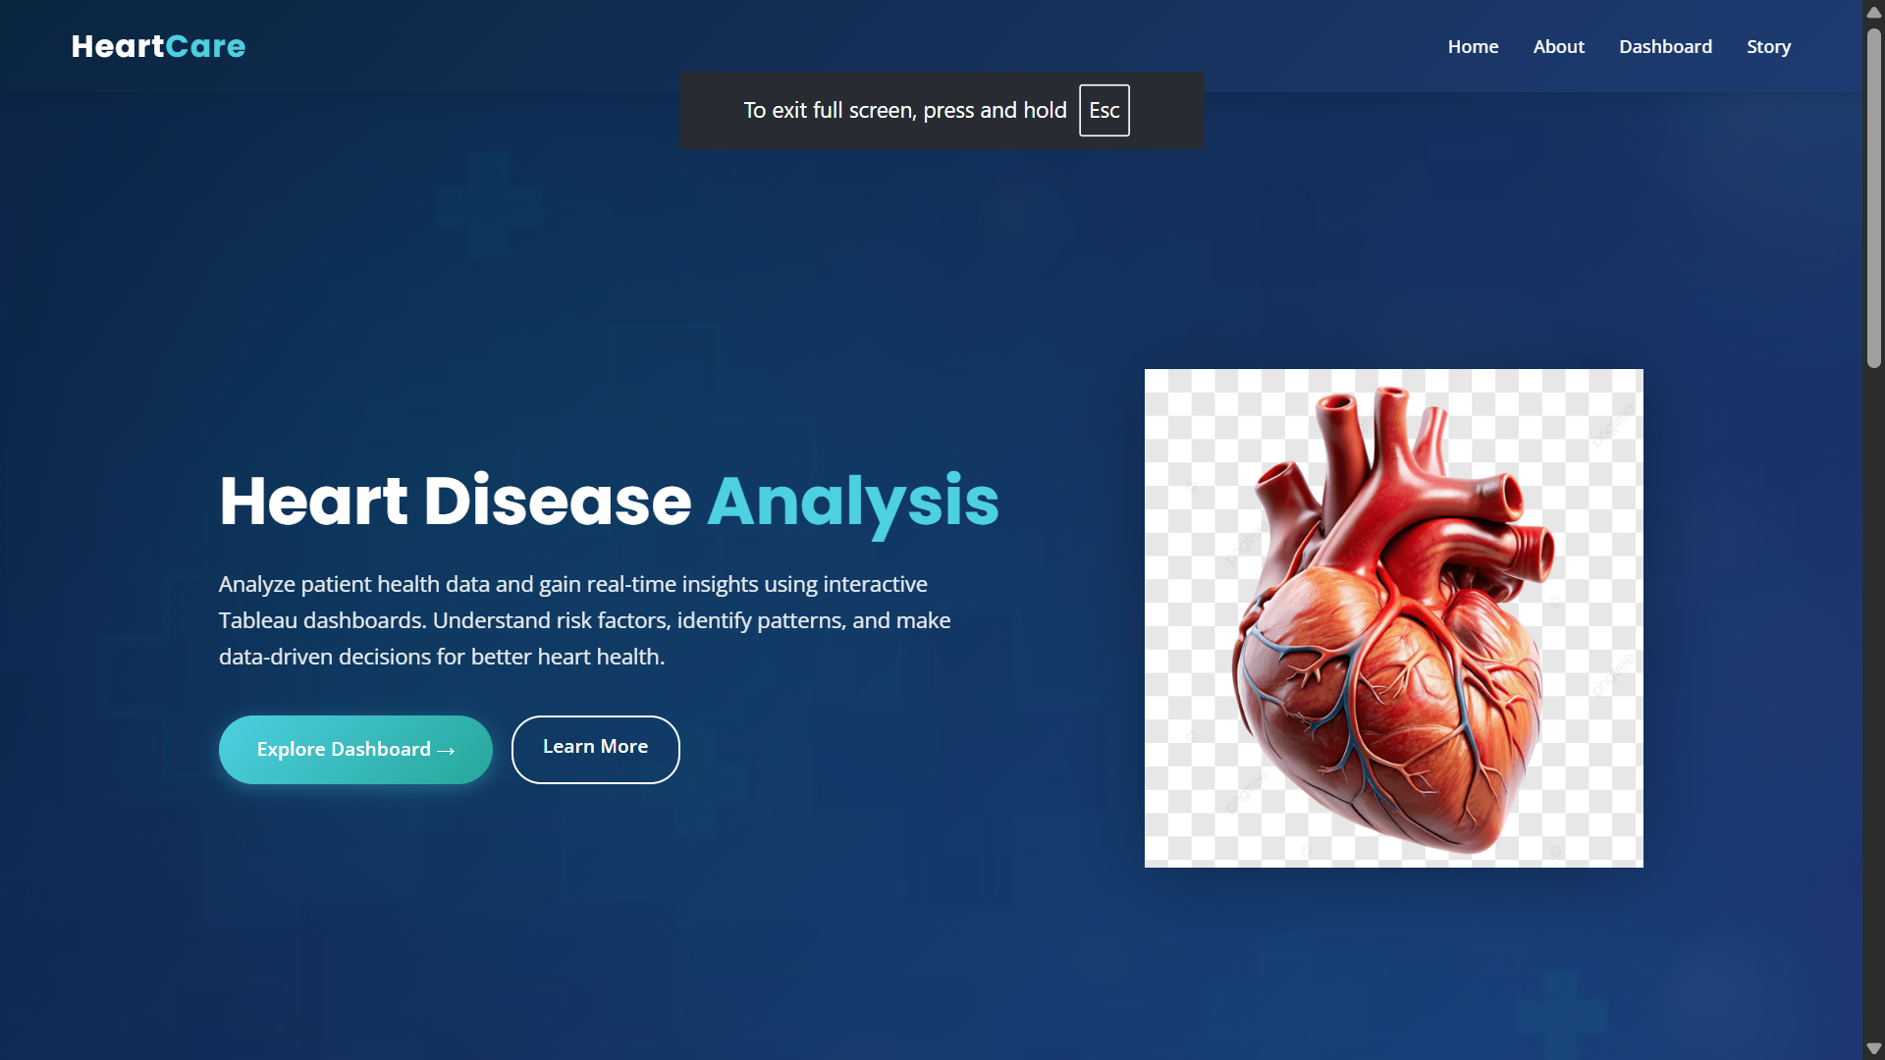
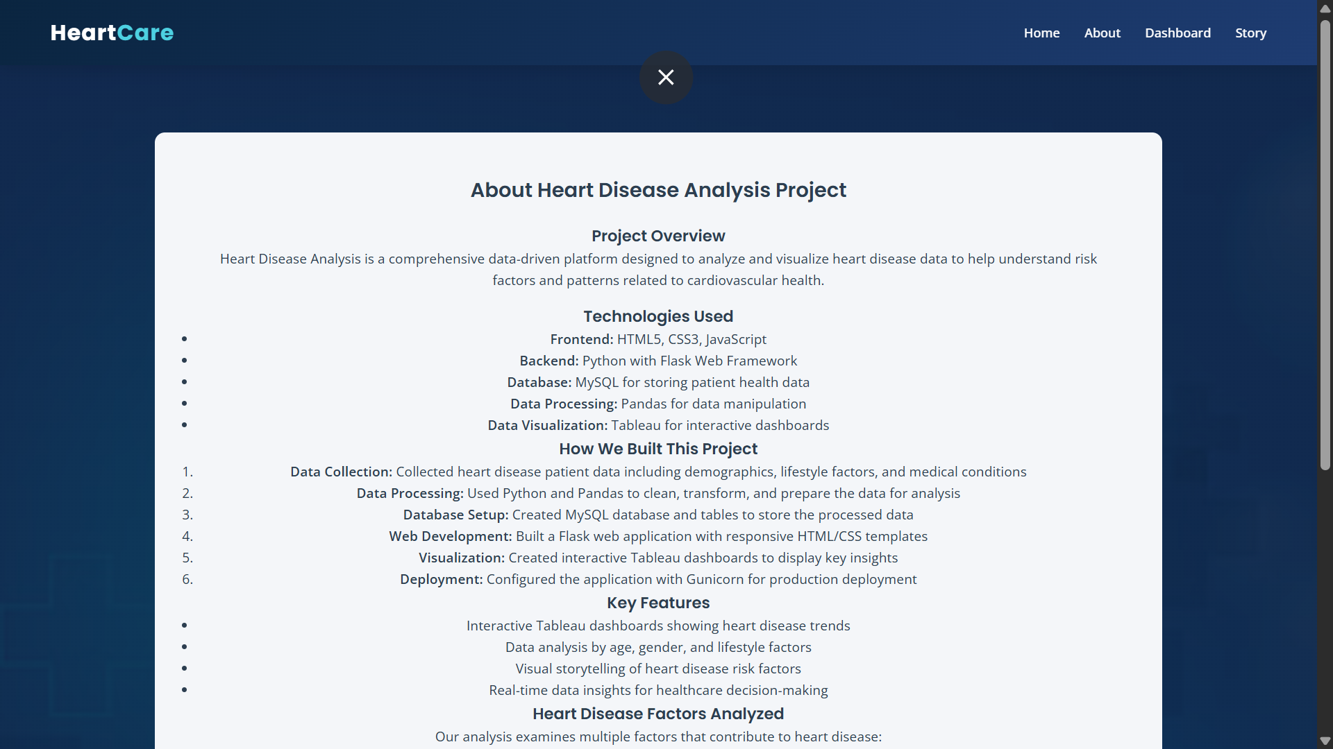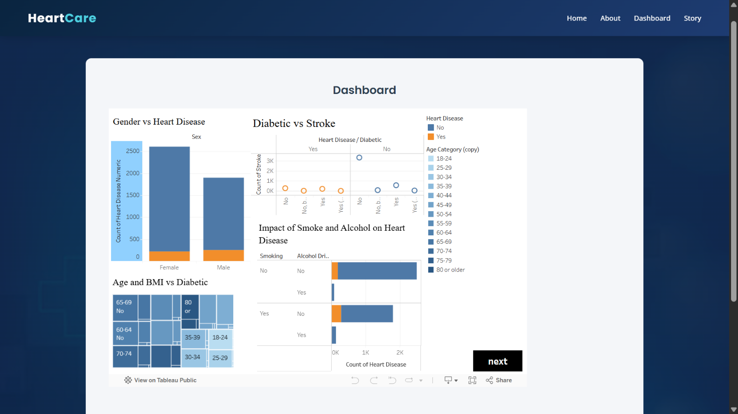
- Benchmark results :
The system performs efficiently with the given dataset and provides accurate visual representations of heart disease risk factors such as age distribution, cholesterol levels, and BMI comparisons.

17. ADVANTAGES & LIMITATIONS
● Advantages :
- Converts complex healthcare data into easy-to-understand visual insights.
- Helps identify high-risk groups based on health indicators.
- Interactive dashboards allow users to explore the data dynamically.
- Supports data-driven decision-making in healthcare.

● Limitations :
- The system depends on the accuracy and completeness of the dataset.
- It does not include predictive analysis or machine learning models.
- Requires Tableau software to create and view dashboards.

18. FUTURE ENHANCEMENTS
The system can be improved in several ways to enhance its capabilities:
- Scalability Improvements: Support larger healthcare datasets from multiple hospitals.
- Feature Expansion: Add advanced analytics and predictive models for heart disease risk prediction.
- Cloud Integration: Deploy dashboards on cloud platforms for easier access and sharing.
- Mobile Integration: Develop mobile-friendly dashboards for healthcare professionals.
- Automation: Integrate real-time data collection from hospital databases or wearable health devices.

19. CONCLUSION
- Summary of Implementation
The Heart Disease Analysis using Tableau project successfully demonstrates how data visualization can be used to analyze healthcare datasets and identify key risk factors associated with heart disease.
- Technical Achievements
The project integrates dataset preparation, interactive dashboards, and visual analytics using Tableau to transform raw data into meaningful insights.
- Practical Impact
The system can support healthcare professionals, researchers, and policymakers in understanding heart disease trends and making informed decisions to improve preventive healthcare strategies.

20. APPENDIX

● Source Code ● Configuration Files ● Dataset Details (if applicable) ● API Documentation ● GitHub Repository Link ● Live Demo Link

